ASSIGNMENT DAY 10

Name: Aafreen

A few pointers related to the assignment

1. This analysis and hypothesis formation is done on the data provided by in the general_data.csv file
2. The mode of assignment submission was unclear, so as per my understanding I have submitted in the form of a word document
3. The exact values for H0 as explained in classes have not been provided, instead a full-fledged statement is given, as I am unable to do so with the amount of understanding I have over the subject right now
4. This assignment was given in day 10 when the practical pyhton implementation of the topic covered in this assignment still remained uncovered, so my understanding on the topic still remains very vague. Nevertheless, I have tried submitting the assignment to the best of my abilities

**1.**

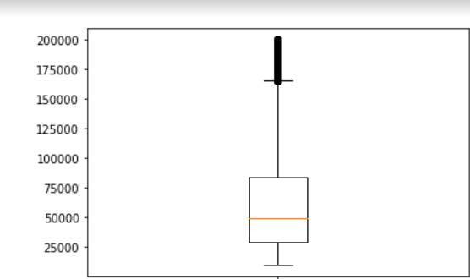

Observation: Monthly Income is Right skewed with several outliers

Hypothesis: Less people are receiving salaries>150000 which could be why the company cannot maintain the admission rate as the most part of the masses is receiving meagre salaries

**2.**

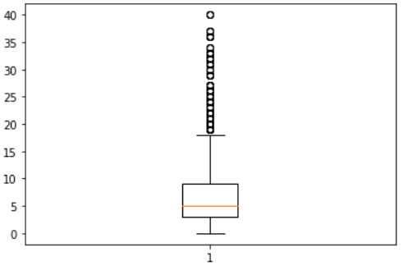

Observation: Years at company is also Right Skewed with several outliers observed.

Hypothesis : People are leaving the companies after working for around 17 years and a very few people stay with the company after 17 years. The employees have absorbed all they could in their 17 years and are now looking for some sort of change or maybe relaxation in their lives

**3.**

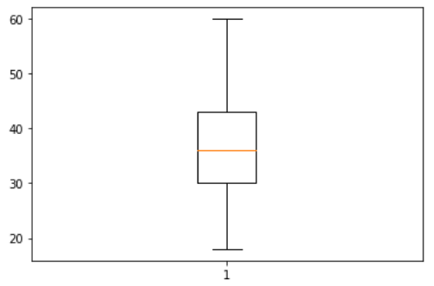

Observation: Mean age forms a near normal distribution

Hypothesis: This just goes to say that that people over all the age groups can be admitted in the company as this one factor is not causing any attrition

**4.**

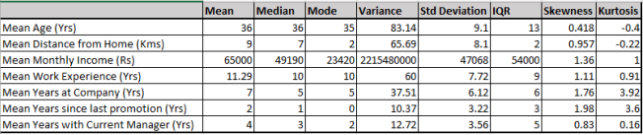 Observation: The variance in the mean monthly income is 2215480000

Hypothesis: The variance in the mean monthly income is big through which we can infer that most of the masses receive very low salaries which results is attrition

**5.**



Observation: all the attributes are positively skewed

Hypothesis: there is no normal distribution in any of the attributes which results in unreliable predictions thus unable to solve problems caused by attrition

**6.**



Observation: the mean years since last promotion is 2

Hypothesis: if promotion is given in every 1.5 years, more employees can be retained

**7.**



Observation: mode of the mean monthly income is 23,420

Hypothesis: most of the employees are receiving salaries of Rs. 23420 which cannot sustain the employees and their families well. Thus, they move out of the company in search of better salaries

**8.**



Observation: skewness is +1.11 for mean work experience

Hypothesis: increasing number of people who have more years of work experience are admitted into the company. If the company reduces the years of work experiences and focuses more on what the candidate has to offer, attrition will reduce

**9.**



Observation: mode of years with current manager is 2

Hypothesis: as many people are stuck with the same manager for about 2 years , they are unable to find any change in terms of work culture as the manager is the same which makes them lose interest in the job

**10.**



Observation: mean distance form home is 9

Hypothesis: if the company can offer on campus residences (if they don’t have any such facilities already) to people living at 9 kms in a subsidised manner, then those employees will have an easier time reaching at the office and will be more productive too. This in turn will reduce attrition